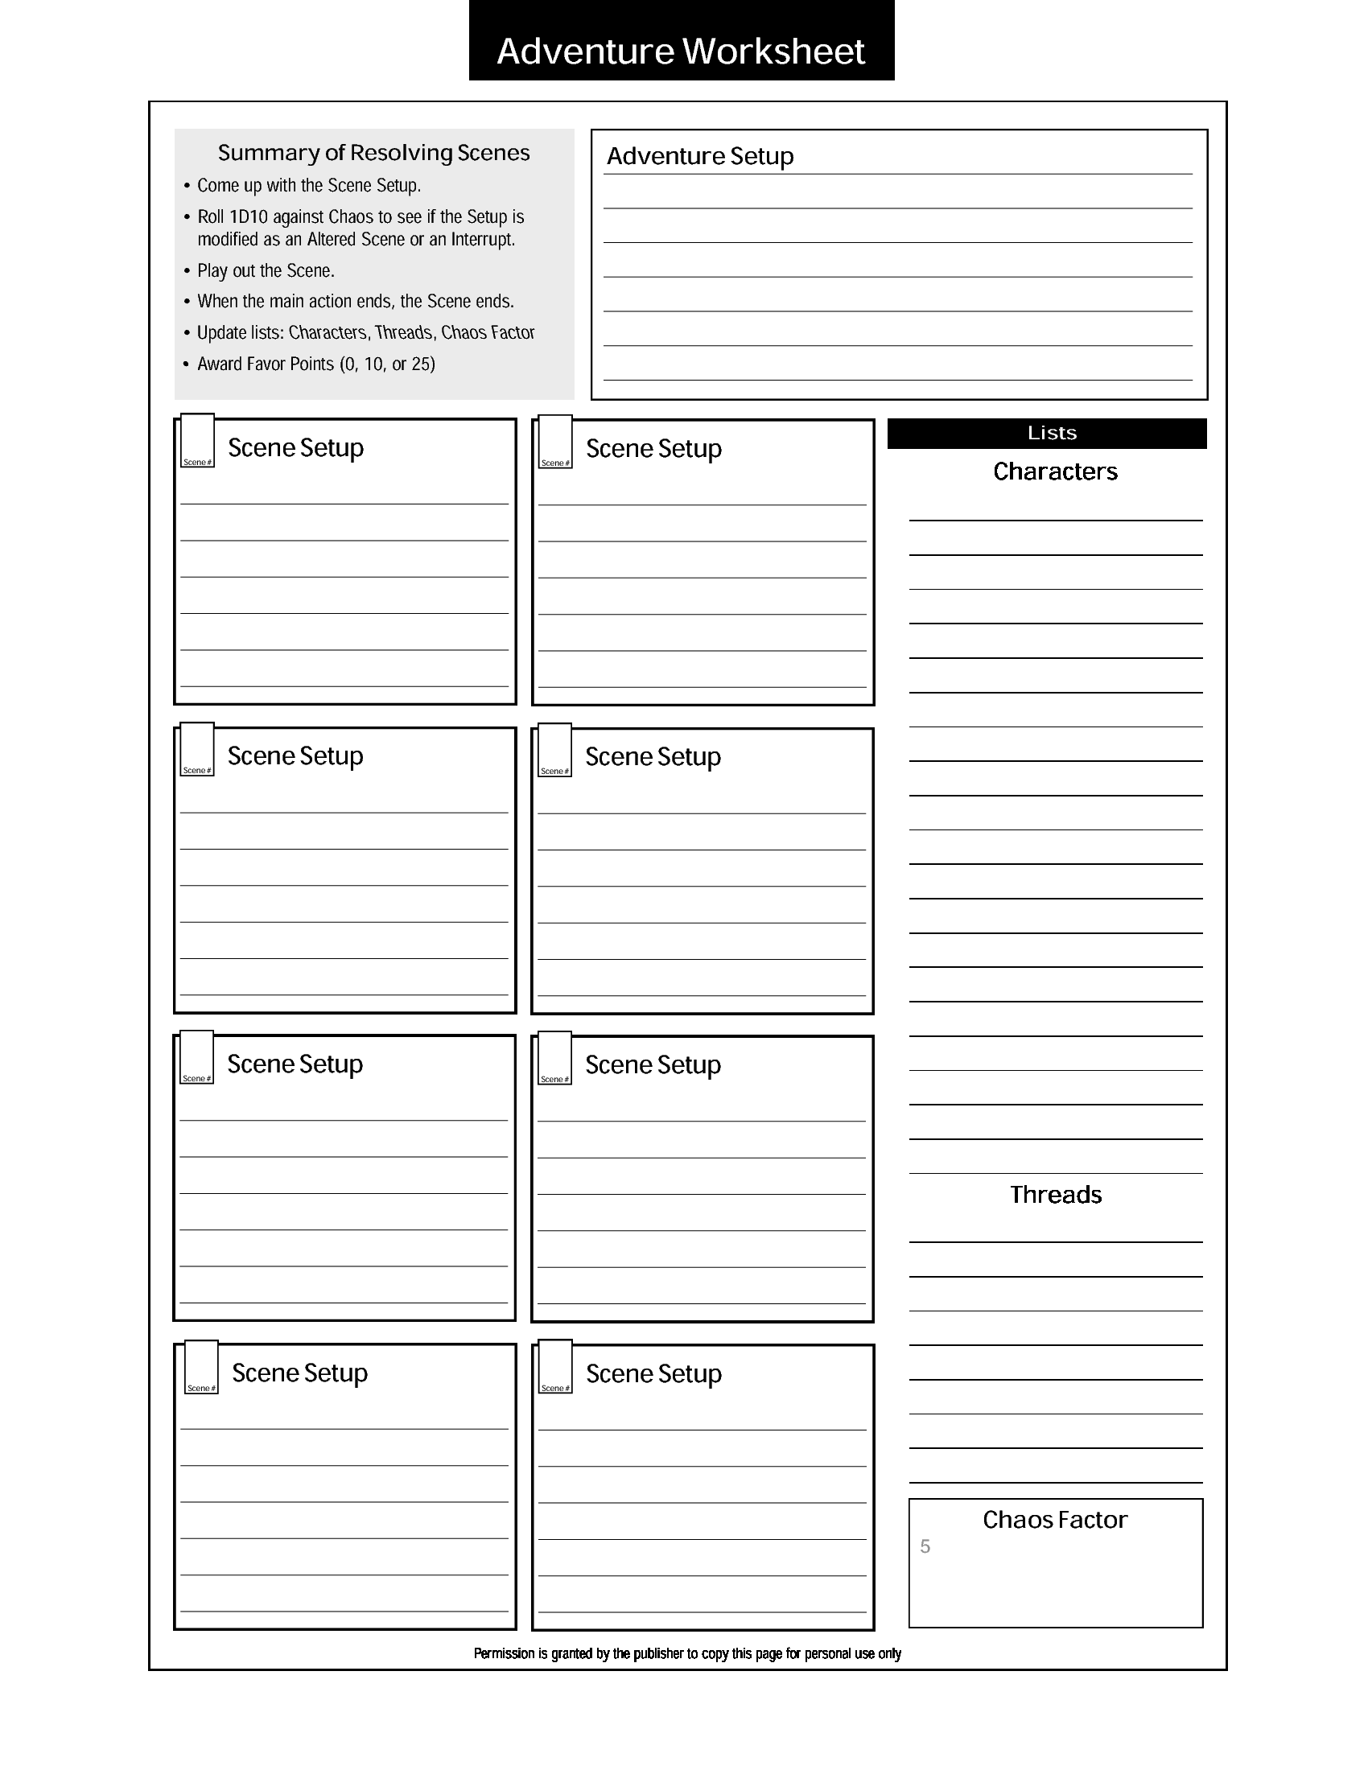

Oneus Earthmane, a local goliath sorcerer believes he has discovered the location of his ancestor’s ancient abode. He hires the character to find the ruined keep, and if possible, bring

back Voran’s greatest creation, the *staff of earthen might.* Oneus knows little about the valley, but cangive the player information on Voran, his keep, and the *staff of earthen might.*

1

Player is approached by Oneus Earthman about retrieving the *staff of earthen might.*

***exit:*** player finishes gearing up in town and journeys to ruins

Voran

Oneus Earthmane

a

2

Player approaches and enters the ruins

***exit:*** must find the secret hatch leading down to the study

a

3

Find the staff

a

4a

~~5~~4